Graphic Design Technology

Test Project Module 1
  - Corporate Design ASC2018_TP_GraphicDesign_M1_PRE_EN

Submitted by:

Mr. Sin Sothona CAM
Mr. Arnold Sandjaja ID
Mr. Soksavanh Phetrasy LA
Mr. Azizul Mohamad Sam MY
Mr. Ronald P. Alvarez PH
Ms. Amy Soon Chieu Gwat SG
Mr. Prasit Kongngooluame TH
Miss Supitchaya Khemthong TH
Mr. Giang Thanh Tron VN

CONTENTS

This Test Project proposal consists of the following documentation/files:
ASC2018_TP40_Day1_CI_EN.doc (Test Project file)
ASC2018_TP40_Day1_APPENDIX01_EN.txt (text file)
ASC2018_TP40_Day1_APPENDIX02_EN (image folder)

INTRODUCTION

Bangkok, one of the world's most attractive tourist destinations comprises of complex
multi-layers of heritage, traditions, religions and ethnicities. In the past, Bangkok thrived with travelers and traders from China, India and Europe who witnessed life on Chao Phraya River and canals with riverboats, rafts and rice barges. Missionaries, diplomats and artists recorded their experience of Bangkok with overwhelming joy and delight. Comparison between Bangkok and Venice became popular as visitors frequently viewed Bangkok as Venice of the East. Visitors are attracted to Bangkok for leisure, warm climate, business, hospitality, cuisine, entertainment and spiritual enlightenment.

Bangkok as city of art and culture is full of rich tradition, creativity and contemporary art. Renowned for heritage, hospitality, entertainment and gastronomy, Bangkok will serve as a grandiose venue for a new international contemporary art festival: Bangkok Art Biennale 2018 and will take place on world famous sites along Chao Phraya River, ancient temples Wat Pho (Temple of Reclining Buddha), Wat Arun (Temple of Dawn), Wat Prayoon (Temple of Iron Fence) will be sites for cultural encounters. Along with historic East Asiatic Company building, Bangkok Art and Culture Center and Suan Lumpini Park.

The Bangkok Art Biennale has met a great international echo. This is reflected in the support of foreign embassies and their cultural institutions in Bangkok. The ambassador of Japan has pledged important support, particularly through the Japan Foundation. The Italian, Russian and Turkish ambassadors are very pleased that we will host this contemporary art event. Australia, as part of its Asian policy, will also contribute and support. France, with the Institute Français de Paris and the Alliance Françoise de Bangkok, like Germany with the Goethe Institute will be involved.

DESCRIPTION OF PROJECT AND TASKS

An international contemporary art festival: Bangkok Art Biennale 2018 will be the first biennale in Bangkok and a new alluring destination for international art scene. Artists, art enthusiasts, writers and media converge in Bangkok for creative encounters that will be held from 19 October 2018 to 3 February 2019 in cooperation with international advisers and artists.
This event is arranged by Bangkok Art Biennale Foundation, known as BAB, is a non-profit foundation that has mission to engage and inspire diverse Thai, ASEAN and international audiences by
- Organizes and contributes to contemporary art experiences for diverse audiences such as conferences, workshop, guided visits and publication.
- Develops and maintains high-profile art activities that promote Bangkok as leading contemporary art destination.
- Provide training, art programs and human resource development for students and volunteers.
- Supports and produces relevant artistic and creative projects by Thai.
- Support for Thai talent in contemporary art to participate in biennales.

Project:

1. Create a logo
2. Create a 16 pages style guide (Corporate Manual)
3. Create a series of 3 accreditation badges

Target group:
People who interested in contemporary art, artists, columnists and tourists.

INSTRUCTIONS TO THE COMPETITOR

- Create a folder on your Desktop called YY_MOD_Day1
(YY represents the number of your workstation).
- This folder must include the following 2 subfolders:
- A folder named “Final”: it should contain all of the final files in subfolders Task 1, Task 2 and Task 3 with PDF, ICC profile, native files, fonts and linked images.
- A folder named “Original”: it should contain other files that are not final files used for creating your design.

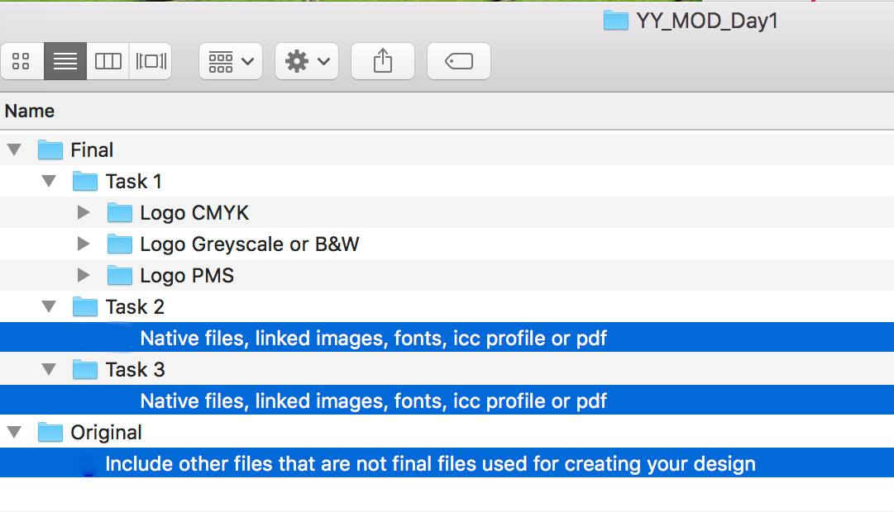
- Regarding image assessment for the tasks:
The color mode of your images will be evaluated in the PDF files. The final resolution and file formats will be assessed in the InDesign files.

- The JPG file format is NOT ACCEPTED for images; Only the following file formats are acceptable .TIF / .AI / .PSD.
- Images must not be embedded or placed in Adobe Illustrator, or embedded in InDesign
- You must use ALL of the text provided for each task as specified.
- You must use ALL of the images specified as per the tasks, and you may create any additional raster or vector elements.

Time limit for this test project
The Test Project must be completed in 6 hours

TASK 1: Create a logo for Bangkok Art Biennale 2018

Target audience
Government departments and private organizations — both nationally and internationally.
People who interested in contemporary art, artists, columnists and tourists.

Concept
Thai Contemporary Life.

Requirements for logo
- The Logo should be in Vector

- The logo must be combination mark.
- The logo must have the word: Bangkok Art Biennale 2018
- The logo must have a yellow circle (Pantone 1345 C) which is this festival’s
corporate graphic
- You must create at least 1 more vector element.
- The logo should NOT include any gradients.

Logo variations
- CMYK Full Color
- 2 PMS of Pantone Solid Coated and one of them must be Pantone 1345 C
- Greyscale OR Black and White
      - The Pantone Solid Coated, CMYK and Greyscale/B&W version should replicate the colors as closely as possible to each other, you should not use colors that cannot be reproduced by another color gamut (eg: do not choose a fluorescent or metallic Pantone Solid Coated color).
      - Include color swatches in each in the logo versions including the color specifications of each color.
      - CMYK & Greyscale/B&W color values should NOT have decimals
(e.g. 2.73%, change to 3%).

Technical specifications

Text :
All text must be converted to outlines.
File Types : Illustrator (Working File)
: PDF/X-4:2010 (Final File)
Trapping : 0.30 pt in CMYK and 2 PMS version (if needed)

Naming:

Folder Logo CMYK
File YY_BAB_Logo_CMYK.ai
YY_BAB_Logo_CMYK.pdf
Folder Logo PMS
File YY_BAB_Logo_PMS.ai

YY_BAB_Logo_PMS.pdf
Folder Logo Greyscale OR B&W
File YY_BAB_Logo_Greyscale.ai or YY_BAB_B&W.ai
YY_BAB_Logo_Greyscale.pdf or YY_BAB_B&W.pdf
(Note: YY represents your competitor number)

You must deliver
Folders as specified in “Instructions to the Competition” on page 4. Only files from these folders will be assessed.
- 3 PDF files. (PDF/X-4:2010)
- 3 Illustrator files, 1 for each version.
- 1 x A4 printout of the CMYK Logo, PMS Logo and Greyscale/B&W version (with color specifications of each color), mounted on mounting board. Ensure that you include your competitor number on the front of the board.

Task 2: Create a style guide (Corporate Manual)

Target audience
- BAB Foundation and Government departments — both nationally and internationally
- Anyone who may need to refer to the style guide (e.g. external or internal designer)

Requirements for style guide
The Style guide must include the following pages:
Front Cover 1
Contents Page 2
Introduction 3
The Logo 4 - 5
The Colours 6 - 7
The Fonts 8 - 9
Unacceptable Logo Usage 10
The Visual Elements 11
The Imagery 12
Brand Implementation 13 - 15
Back Cover 16

(further information, refer to the appendix file ASC2018_TP40_Day1_APPENDIX01_EN.txt)

Technical specifications

Size & Page Specifications :
297mm wide x 210 mm high (A4 Landscape)
Single pages only.

File Types :
InDesign (Working File)
Any additional elements (links): AI, PSD, PDF, TIF
: PDF/X-4:2010 (Final File)
Bleed : 3 mm
Color Specifications : CMYK + 2 PMS (from Task 1)
PMS logo should use it at page 4-5, page 6 and back cover.
You can use in other page on your demand.
ICC Profile : Coated FOGRA39 (ISO 12647-2:2004)
Image resolution
: 280-300 PPI at 100% in InDesign
Bitmap image resolution : 800-1200 PPI 100% in InDesign
Naming :
YY_BAB_Style_Guide.indd
: YY_BAB_Style_Guide.pdf

(Note: YY represents your competitor number)

You must deliver
- Folder as specified in “Instructions to the Competition” on page 4. Only files from these folders will be assessed.
- 1 InDesign file (including ICC profile, fonts and linked images).
- 1 PDF file (including bleed, specified output profile, color bars for CMYK + PMS, registration marks and crop marks).
- 1 x double-sided printout of the style guide printed on A4 landscape.
(reduced to fit with no crop/bleed). There is no requirement to staple.

Task 3: Create a series of 3 accreditation badges
BAB security service require a series of 3 accreditation badges to identify groups of people in each venue. The badges must have graphic design elements to communicate their visual identity of each group and be consistent with one another, yet can be clearly identified as the certain group range as specified below.

Badge 1: Staff
Badge 2: Artist
Badge 3: Audience

The badge will be also used as a pass card of every venue.

Target audience
- Everyone who join the Bangkok Art Biennale 2018
- BAB security service staff

Required elements
Each accreditation badge must include the following elements:
- BAB Logo PMS. Use a spot varnish.
- Text: 19 Oct 2018 - 3 Feb 2019 (use font(s) as specified in the style guide)
- Name of each group (use font(s) as specified in the style guide)
- barcode in 100% Scannable color and 30mm wide
- You must use at least 1 image on each badge.
- The images can be manipulated to suit the design and/or the visual identity of each group.
- You can use any image from the appendix folder ASC2018_TP40_Day1_APPENDIX02_EN.

Technical specifications

Dimension : 85 mm wide x 130 mm high (Must be vertical layout)
File Types : Illustrator - Any additional elements (links): PSD, TIF
: PDF/X-4:2010 (Final File)
Color : 2 PMS color + spot varnish must be named “varnish”
ICC Profile : US Sheetfed Coated v2
Bleed : 3 mm
Trapping : 0.30 pt (if needed)
Image resolution : 280 to 300 PPI at 100%
Bitmap image resolution : 800 to 1200 PPI at 100%

Naming YY_BAB_Badges.ai
YY_BAB_Badges.pdf

(Note: YY represents your competitor number)

You must deliver
Folder as specified in “Instructions to the Competition” on page 4. Only files from these folders will be assessed.
- 1 Illustrator file (including ICC profile, fonts and linked images).
- 1 PDF file (including bleed, specified output profile, color bars for 2 PMS C+ varnish at 100%, registration marks and crop marks).
- Printout of 3 badges, trimmed to size at 100% mounted on A4 mounting board without varnish. Ensure that you include your competitor number of the front of the board.
- 1 Printout on A4 with the varnish on top of the design (the varnish area needs to be 30% transparency).

